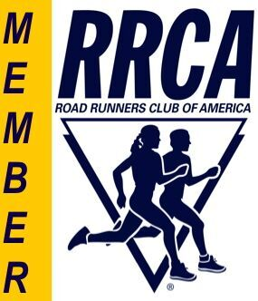
Mid-Pacific Road Runners Club
Membership Application
On-line sign-up is available at RunSignUp.com
Just go to www.mprrc.com/join and click on RunSignUp under “Apply Online”
The Mid-Pacific Road Runners Club organizes or helps with races throughout the year. We get together socially for an annual meeting and awards banquet honoring our outstanding runners, and for periodic gatherings. We post race results, pictures and feature stories on our web site at www.mprrc.com. The Club phone line—(808) 295-MPRR (6777)—provides timely information on upcoming races and records voice mail messages.
Club races are open to the public, but members are eligible for discounted entry fees. Members also receive discounts at some running stores. Members are encouraged to serve the club as volunteers for at least one race per year. Mid-Pacific Road Runners Club depends on the help of its member volunteers.
In what ways would you like to contribute to the life of your running club? Please check items below:
____Race direction (obtain permits, course layout, course marshals, police, aid stations)
____Equipment and support (pick up and set up equipment)
____Registration and finish line (including packet pickup)
____Social committee (plan meetings and events)
____Data processing; website (update website; race results)
____Other_______________________________________________________________________________

Please print, filling out a separate form for each family member

Last Name_________________________________ First Name__________________________
Make check payable to:
MPRRC

Mail form and payment to:

MPRRC
c/o Paula Carroll
4791 Analii Street
Honolulu, HI 96821

Amount enclosed:

$________________

Address________________________________________________________________________

City________________________________________________State_____Zip_______________

Phone (day)__________________________Phone (evening)___________________________

Email__________________________________________________________________________

Date of Birth (MM/DD/YY) _____________________ Age ______ Gender (circle one):

Membership type: New_____ Renewal_____ Male Female

Annual Membership Dues:
Junior (under 19) - $20 Individual - $30 Family (spouses, partners, dependents under 19) - $40

Lifetime membership - $600

Optional Tax Deductible Donation to MPRRC $______________
Enter the total amount (dues plus optional donation) in the box above right.

Member’s Affidavit: I know that running and volunteering to work in club races are potentially hazardous activities. I should not enter and run in club activities unless I am medically able and properly trained. I agree to abide by any decision of a race official relative to my ability to safely complete the run. I assume all risks associated with running and volunteering to work in club races including, but not limited to falls, contact with other participants, the effects of the weather, including high heat and/or humidity, the conditions of the road and traffic on the course, all such risks being known and appreciated by me. Having read this waiver and knowing these facts, and in consideration of your acceptance of my application for membership, I, for myself and anyone entitled to act on my behalf, waive and release the Road Runners Club of America, the Mid-Pacific Road Runners Club and all sponsors, their representatives and successors from all claims or liabilities of any kind arising out of my participation in these club activities even though that liability may
arise out of negligence or carelessness on the part of the persons named in this waiver.

Signature (parent if applicant under 19): ______________________________ Date: ____________

